|  |  |
| --- | --- |
| *Parent Society*  Project Proposal for a Responsive Website | Author: Aanan Abdullah  Student ID:220499062 |

Unit: SIT120 Introduction to Responsive Web Apps

Table of Contents

Product Summary 1

Product Purpose 2

Target Audience 2

Presentation of Creativity 3

Asset List 4

Intended Behavior 7

Components Explanation 7

User Stories 8

UX/UI Design 11

Written UX/UI Features 11

Key Desktop UX/UI Features 12

Key Mobile UX/UI Features 12

UX/UI Design in Figma 14

Figma Desktop Version 14

Figma Mobile Version 16

Figma UI/UX Prototype 16

Larger System Summary 17

Component Integrating 17

Concept Functionality 18

Development Schedule 19

# Product Summary

This responsive application is an online community website for parents, caregivers, or guardians with children of various ages. The website is called Parent Society and consists of diverse resources and tools each aiming to provide assistance about different aspects of parenthood.

Parenting is an extremely daunting task especially for first-time parents or for parents without an adequate support system. They may experience difficulties in accomplishing necessary childcare chores like feeding, bathing, changing diapers, etc.; in addition, they might be living far away from any family members who could teach them how to complete such childcare chores. Moreover, parents often do not find sufficient time in their busy schedules to take care of themselves or socialize since many parents must juggle both professional and domestic duties.

This website has three key functionalities. Firstly, it will allow users to register and create custom profiles containing personal details. Parents can peruse through the profiles and interact with other parents either through chats or videocalls. Secondly, the users will have access to a wide variety of curated content that includes instructive videos about basic childcare chores, verified latest news about childcare in general, online shopping recommendation links to assorted children’s products, tips to keep children entertained, and finally self-care information for parents. Lastly, the users have the option of signing up for a monthly digital newsletter which provides a condensed version of the website’s latest content if users happen to miss out on anything in a particular month. Most importantly, users can access this website from any type of device that is convenient for them because of its responsive design.

# Product Purpose

## **Target Audience**

|  |  |  |
| --- | --- | --- |
| **Target Audience** | **Reasoning** | **Benefits from Website** |
| Couples with children from ages 0 to 10 years old | The initial years of parenthood are the most challenging since children are completely dependent on their parents during younger years. So, these parents require a significant amount of assistance mainly with their first child/children. | * The various types of resources are all divided into separate pages highlighted as hyperlinks in the top navigation bar so they are easy to locate. * They can find and interact with other parents of similar backgrounds and domestic situations by perusing through the custom Profiles page. * The Playdates page contains constructive ideas about educating their children on relevant topics and suggestions to keep them occupied. |
| Single parents/guardians/  caretakers  With children from ages 0 to 10 years old | Partners or married couples have enough difficulty raising children with each other’s help so it is even more intimidating to raise a child or children without a significant other’s aid. Furthermore, single guardians often struggle to properly balance both professional and personal duties. | * People in this category might not have the time to extensively search for children’s products, but the Products already does the work for them by listing all the links to the any required products. * They struggle to take care of themselves since they have to devote extra time toward their children so the activities and articles from the Self Care will teach them how to balance efficiently make the time for themselves. * They might not always have the time to constantly check and be up to date about the website’s content. The monthly newsletter can solve that issue. |
| Parents with children from ages 0 to 10 without any extended family | Usually extended family members like maternal/paternal grandmothers and grandfathers, aunts, uncles, etc. teach new parents how to complete the essential childcare tasks; however, if these family members live in another part of the world, or the parents lack such figures in their life, then they might seek an external source of help for guidance. | * The Learning page contains instructive videos on essential childcare tasks like feeding and bathing so they can learn by watching them. * They might be confused about which online sources to trust; the news page lists parenting related articles from verified sources. |

## **Presentation of Creativity**

This website encapsulates a wide range of child related advice and information in a single place. Parents do not have to search or invest any extra effort by combing through numerous online or paper sources. The website does all the work for them, and that too without any remuneration. There are certified experts who teach classes about primary childcare tasks and give detailed tips on successfully tackling numerous childcare problems. However, most if not all of them are paid classes and are usually offered in more developed countries. Many families might not be able to afford these classes because of increased expenses of raising children. This website offers all of its content for free and can be accessed by anyone from across the world if they have computer or smartphone and a reliable Internet connection.

Since 2020, Covid-19 has ravaged our world and drastically changed everyone’s lives. Even though, several countries around the world are slowly opening up as more and more people get vaccinated, new variants are being frequently being discovered. As a result, even if there are parents who can afford to pay for childcare classes, it is still somewhat unsafe for face-to-face recreational activities. Many businesses are shifting their services online to keep up with the rapidly changing times. This website is innovative from its creation itself as it is taking services that were normally offered physically to an online platform. Also, the custom profiles allow parents to connect with other parents from anywhere across the world. They can expand their horizons and might even accumulate more advanced information which would not have been possible when they are limited to interacting with parents from only their area.

# Asset List

|  |  |  |
| --- | --- | --- |
| **Asset** | **Description** | **Details** |
| Proof-of-concept.html | This is the main page of the website and is the user’s entry point into the website because they will use the login button to sign in or register for an account. It contains a search function that will accept text input from the user about custom profiles, articles, or instructive videos and list the matching entries. There is also a navigation bar with hyperlinks of all the other website pages in addition to the hyperlink to sign up for the newsletter along with its sample picture. The main section of the page contains a description of the website and contact information. Lastly, the footer contains a quote. | This is an interactive HTML page since it contains a search function and hyperlinks of other HTML pages in the website. It is organized in a grid layout; additionally, it is a responsive page where the grids merge into a single column, and the footer disappears in smaller devices like smartphones and iPads. Internal CSS elements are used because a significant portion of the CSS is custom for the entire page. A few inline CSS elements are used for particular HTML tags where the Internal CSS needed to be overridden. There is a JavaScript file linked as well which is responsible for opening up a login form when the user clicks on the Login button. The login form has hyperlinks to a Sign-Up form if the users are new and a Forgot Password function if users forget their passwords. |
| Profiles.html | This page will contain the users’ custom profiles where they will be able to choose and interact with other users through either a chat or videocall function. | This will be a dynamic and interactive HTML page since users will chat or videocall with other users through this. It contains an external CSS file. It will also be responsive and become a single column to fit smaller screens. |
| Learning.html | This page will contain instructive videos about basic childcare tasks. There will also be a search query where users can type in text to find particular videos, and a list with matching entries will be displayed. | This will be an interactive HTML page since users can search for videos using the search function. It will also be responsive and become a single column to fit smaller screens. |
| News.html | This page will contain news articles about parenting, childcare, and any other related topics from verified sources. This page will also have a search query so that users can easily find their desired articles. | This will be an interactive HTML page since users can search for certain news articles. It will also be responsive and become a single column to fit smaller screens. |
| Products.html | This page will contain product images, short descriptions about the products, and shopping links to other e-commerce websites for a wide range of necessary or optional children’s products. This will have a page number functionality for users to go to particular pages. | This will be a static HTML page because users will click on page numbers to go to other pages. They can only view product images and go to links to other e-commerce websites with more interactive features. It will also be responsive and become a single column to fit smaller screens. |
| SelfCare.html | This page will list steps to complete numerous productive activities that will boost both the physical and mental health of parents. There will be an accountability function that they can utilize to check off on activities they have already successfully completed. | This will be a static HTML page because users will only read about the steps to complete activities and mark off the activities they completed. It will also be responsive and become a single column to fit smaller screens. |
| Playdates.html | This page will contain tips, tricks, and games to keep young children occupied. Moreover, it will discuss how to discuss sensitive topics with children. | This will be a static HTML page because users will only read the tips and suggestions and have no option of providing any input. It will also be responsive and become a single column to fit smaller screens. |
| NewsletterForm.html | This page contains a form that receives text input from the user about their identification details so that they can sign up for a monthly digital newsletter. | This is an interactive HTML page because it allows the user to enter input texts. |
| style.css | This file contains details for the page body’s background color, the paragraph’s style details, and other styling details for various HTML tags contained in the different website pages. | This is a static external CSS file and is linked to Profiles.html, Learning.html, News.html, Products.html,  SelfCare.html, and Playdates.html. |
| main.js | This file currently contains JavaScript functions for opening up a hovering Login portal when the user clicks on the Login button in the Index page. There is also an alert function that is activated when a user clicks a submit button to make sure they have correctly filled in all the input boxes in a form. | This is a static JavaScript file and is currently linked to Proof-of-concept.html and NewsletterForm.html. |
| app.vue | The main component which includes all the other child Vue components. | This will be a single file component. |
| search.vue | The Vue application that uses list rendering to display the options after the user types in keywords in the search bar to look for custom profiles,articles,instructive videos,etc. | This will be a single file component and will be an interactive page listing the matching items whose names match with the keywords the user typed. |
| customprofile.vue | The Vue application that will use list rendering to display the custom profiles for parents who already registered and created an account on the website. | This will be a single file component and static where the user can peruse through custom profiles. It will be linked with the Profiles.html page. |
| text.vue | The Vue application that will process the texts being communicated inside the chat box on the Profiles page. | This will be a single dynamic file component as it will process user input in real time. This will also be linked with the Profiles.html page. |
| chat.vue | The Vue application that will represent the chatting functionality on the Profiles.html page that will allow parents to contact other parents. | This will be an interactive single file component as it will allow users to receive real time text responses from other users. This will also be linked with the Profiles.html page. |
| loginconfirm.vue | The Vue application that will be displayed after the user has successfully submitted the form for the monthly Newsletter. | This will be a static single file component since it will only display some form of text-based confirmation to the user. |
| register.vue | The Vue application that will allow new parents to create a custom profile and register for the website. After registering, parents can then just login to access the website’s facilities. | This will be a single file interactive file component since users will be dynamically putting in their information. Each user will have a different set of information to create his or her custom profile. |

# Intended Behavior

## Components Explanation

|  |  |
| --- | --- |
| **Component** | **Explanation** |
| Props | Vue applications can be divided into independent components that form a tree-like Document Object Model (DOM). Components can be nested inside each other and be reused in other Vue instances. Props are a way to pass data to child components from parent components. Props will be used to pass metadata to custom profiles like user image, name, details, etc. |
| List Rendering | List Rendering displays a list of items encapsulated within an array which is a special type of list containing elements of the same data type. The directive v-for iterates through an array to display all the items listed inside the array. There are particular methods like push(), shift(), sort(), etc. that can be used to further update or modify rendered lists. This will be used to display the results when the user types in any keywords in the search bar within the website. |
| Conditional Rendering | Conditional Rendering displays items based on Boolean values. The directive v-if is used to check whether an instance inside the Vue application is true or false. A certain block will only be rendered if the Vue instance is true. Otherwise, different conditions can be defined if the Vue instance is set to false to render a different block. This will be used several times throughout the website specially to verify the legitimacy of the user’s login details. The user will only be able to view and chat with custom profiles if they have created their own profiles and are logged in properly. |
| Custom Events | Vue can listen to events on elements and trigger certain functions to run when the events are called. Events are used to emit some events between parent and child components. They are case-sensitive so exact syntax must be always maintained. This will be used with text.vue and chat.vue to event the text functions between these related components. |

## **User Stories**

|  |  |  |  |
| --- | --- | --- | --- |
| **Statement** | **Acceptance Criteria** | **Estimation** | **Priority** |
| As first time Parent Society user, I want to create a custom profile so that other people can contact me based on my profile. | 1. The user should be able to access a registration form. 2. The registration form should have input areas where the user can input their personal details allowing customization. 3. The user should be able to add a profile picture to identify themselves. 4. The hyperlink to the registration form should be in an easily accessible location. | According to the T-shirt sizing estimation approach, this can be considered as a **Medium.** | **Priority**:1  High Priority |
| As a mobile Parent Society user, I want to access the website on small screen devices so that I can view the website at my convenience. | 1. The entire website should contain responsive elements that adjust to various screen sizes. 2. All the website’s content should be rendered properly. 3. All the buttons, search functions, and forms should be accessible and should function properly. 4. All the website content should be rendered in a column to avoid horizontal scrolling. | According to the T-shirt sizing estimation approach, this can be considered as a **Large**. | **Priority**:1  High Priority |
| As a single parent, I want to interact with other parents so that I can socialize and receive some tips from them. | 1. The user should be able to locate other custom profiles. 2. A chat or video call functionality should be present so that the user can interact with other parents. 3. The chat or videocall functionalities should be accessible at all times. | According to the T-shirt sizing estimation approach, this can be considered as an **Extra Large.** | **Priority**:1  High Priority |
| As a busy parent with young children, I want to quickly find instructive videos or articles so that I can learn childcare tasks from them. | 1. The user should be able to input text in a search bar. 2. The search function should list all matching entries to the user’s input text. 3. The search bar should be located on the relevant pages where the user wants to search for items. | According to the T-shirt sizing estimation approach, this can be considered as **Large.** | **Priority**:1  High Priority |
| As a Parent Society user, I want to easily locate the different sections of the website so that I can utilize their numerous services easily. | 1. The different pages of the website should be clearly labeled and listed in a navigation bar. 2. The user should not have to spend a lot of time looking for the navigation bar. 3. The hyperlinks inside the navigation bar should function correctly. | According to the T-shirt sizing estimation approach, this can be considered as **Small.** | **Priority**:1  High Priority |
| As a Parent Society User, I want be logged in to the website until I explicitly log out so that I do not have to spend time repeatedly logging in. | 1. The website should ask the user to log in when they access it from a new device. 2. The user should stay logged in once they successfully log in on a device. 3. The user should only be logged out if they explicitly press the logout button on a device. 4. After a long period of inactivity, the user should be automatically logged out to avoid any unauthorized activity. | According to the T-shirt sizing estimation approach, this can be considered as **Medium.** | **Priority**:1  High Priority |
| As a Parent Society user, I want to properly access the hyperlinks in the News section of the website so that I can share the links with others. | 1. The user should be able to easily locate and access any hyperlinks included in the News Section of the website. 2. The hyperlinks should all be working properly to redirect to the intended page containing any articles. 3. The user should be able to copy/paste the hyperlink to share with others. | According to the T-shirt sizing estimation approach, this can be considered as **Small.** | **Priority**:1  High Priority |
| As a parent with a heavy work schedule, I want to receive monthly newsletters so that I do not miss out on any of the website’s updates. | 1. The user should be able to fill out a form about their contact details to receive the newsletter. 2. The newsletter should be systematically sent out on the same week each month. | According to the T-shirt sizing estimation approach, this can be considered as **Medium.** | **Priority**:1  High Priority |
| As a Parent Society user, I want to check off the activities I already tried in the Self Care section so that I remember to try new activities. | 1. The user should be able to press a button to check off the activities they have tried in the Self Care section of the website. 2. The user should frequently have access to new unmarked activities in the Self Care section. | According to the T-shirt sizing estimation approach, this can be considered as **Medium.** | **Priority**:2  Medium Priority |
| As a Parent Society user, I want to find the contact information of the website creators so that I can provide feedback to them if necessary. | 1. The website should include the contact information of the website creators. 2. The user should easily be able to locate the contact information without putting in a lot of effort. 3. The contact information should be valid and up to date. | According to the T-shirt sizing estimation approach, this can be considered as **Small**. | **Priority**:2  Medium Priority |
| As a Parent Society user, I want to view the website in soothing colors so that I do not strain my eyes. | 1. The website should have minimal colors. 2. The user should be able to view the website’s content without straining their eyes. | According to the T-shirt sizing estimation approach, this can be considered as **Medium.** | **Priority**:2  Medium Priority |
| As a Parent Society user, I want to open the images provided in a new tab so that I can them view them enlarged. | 1. There should be an option for the user to click on an image and choose to view it on a separate tab. 2. All the images in the website must be displayed properly. | According to the T-shirt sizing estimation approach, this can be considered as **Small**. | **Priority**:3  Low Priority |

# UX/UI Design

## **Written UX/UI Features**

|  |  |  |
| --- | --- | --- |
| Light Blue  Hex: #B7CDFF | Pink Hex: #EECCEE | Dark Red  Hex: #7A1212 |

The website has an overall pastel theme with dark tones for the text. The main background color is light blue while the background color of the smaller portions of the website is pink. All the text is in dark red. I chose a pastel theme so that it is soothing on the user’s eyes since they might be using the website for a long time when they are trying to learn something; I did not want them to strain their eyes. Moreover, the overall colors are synonymous with the website’s main content about children. Usually, people associate light blue with baby boys and pink with baby girls.

### Key Desktop UX/UI Features

* **Consistent Navigation Bar**: The desktop version of the website has an easily visible and accessible navigation bar that contains all the hyperlinks clearly labeled to the different pages within the website. The user can quickly locate which page they need to access by only clicking a link once. The login form is also available from the navigation bar by clicking the login button once.
* **Header Search Bar**: The desktop version also has a search bar located on the Home, Profiles, Learning, and News pages so that users can locate any item they want in the particular page by just typing the item’s title in the search bar. This will greatly save their time because they would not have to peruse through all titles just to find what they want.
* **Content Arrangement**: The website’s layout is structured as a grid especially in the Home page so that different sections of the page are physically divided up into box-like spaces. The user does not have the division on their own; they will immediately know that two pieces of content are on separate topics because of their location in different grid-boxes. Furthermore, each distinct topic inside a page is clearly labeled with headings that give an idea of what that topic is focused on.
* **Visible Footer**: The footer will contain some metadata about each page or some extra graphics/quotes to enhance the website’s overall aesthetic. Since it is at the bottom of the page, it will not have any important information inside it as users might not always scroll all the way to the bottom when they are looking through the website.

### Key Mobile UX/UI Features

* **Consistent Navigation Bar**: The navigation bar will still clearly be visible as a single bar on top of the page below the header. The font size and padding of the labels inside the navigation bar will decrease to accommodate all the labels in the smaller width space found in tabs and smartphones. The other website pages will still be accessible through a single click, and the login form will also still be accessible by clicking the login button.
* **Content Layout**: All the content will still be visible in a grid layout; however, the grid-boxes will be rendered as a single column. The user will only have to scroll up/down vertically and can avoid horizontal scrolling which is often an inconvenience in smaller screens. There will still be headings to distinguish different topics from each so that the user can instantly pick what they want to further read by only looking at the section headings.
* **Header Search Bar**: The search bar in the header will still be visible for smaller screens however its padding and margin sizes will be decreased to accommodate it in smaller screens. The users can still type in text to quickly locate their desired topics in the websites.
* **No Footer**: Since the footer will only contain optional content to enhance the website’s aesthetic, it is not necessary for the viewers to successfully access any content from the website. As a result, it will be removed in smaller screens to render the other more important topics clearly.

## UX/UI Design in Figma

*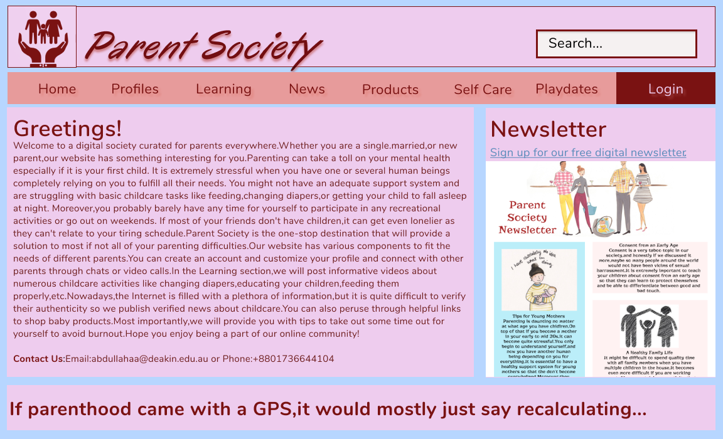**Figma Desktop Version*

User Story 12: Viewing the website in soothing colors

User Story 10: Contact information of the website creators

User Story 5: Visible navigation to locate other parts of the website.

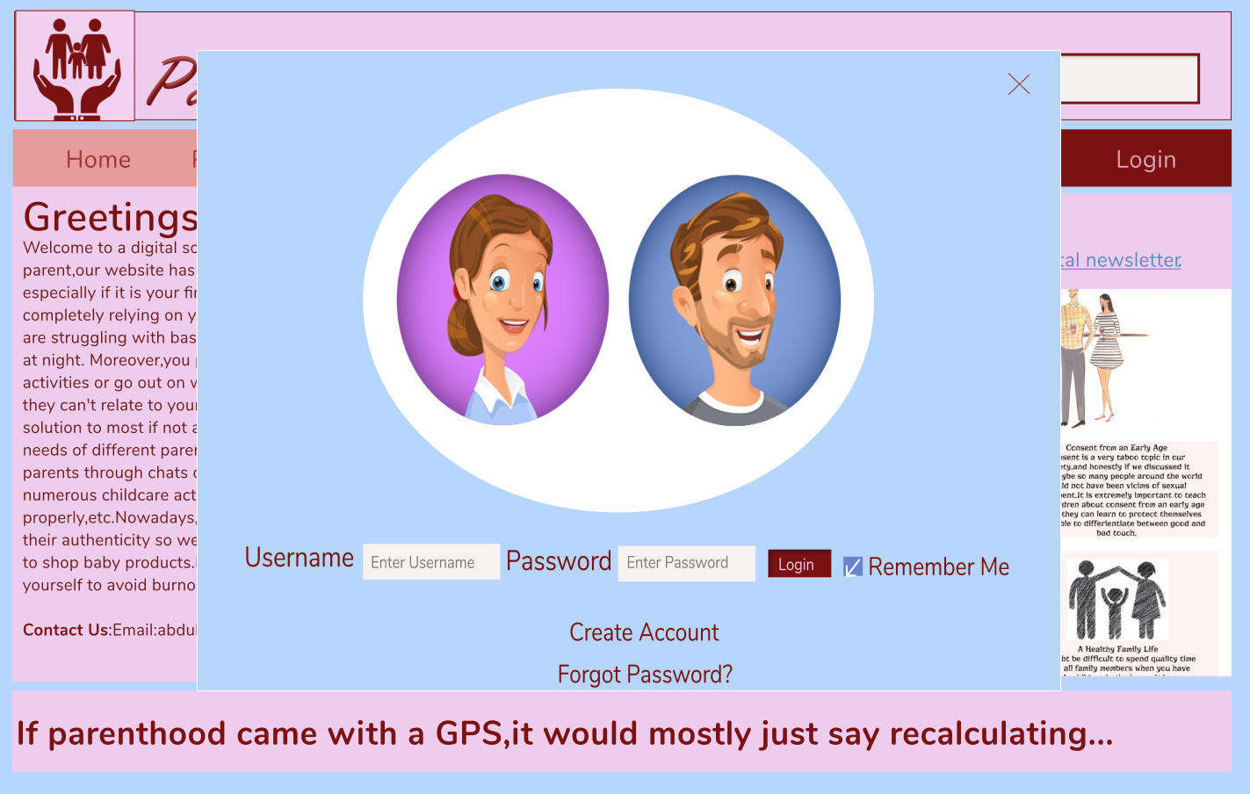

Figure 1 Desktop Home Page

Figure 2 Desktop Login Form

User Story 8: Filling out a contact form to receive monthly newsletter

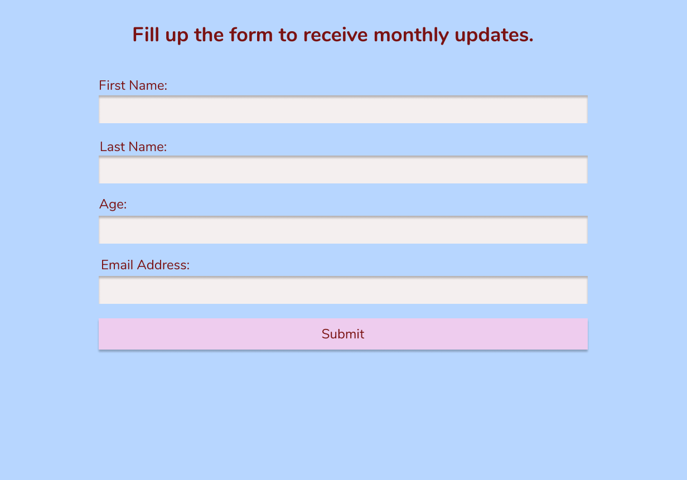

User Story 12: Enlarging image in a different tab

Figure 4 Newsletter Image Opened and Enlarged in Separate Tab

Figure 3 Desktop Newsletter Form

### Figma Mobile Version

User Story 2: Accessing the website on a small screen

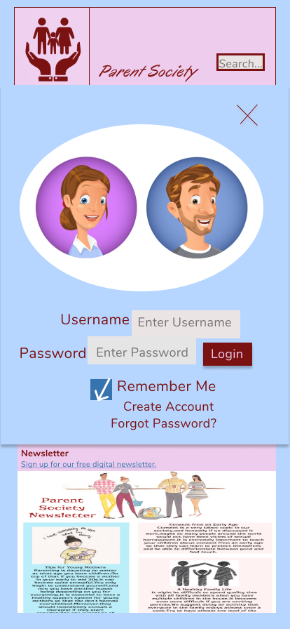

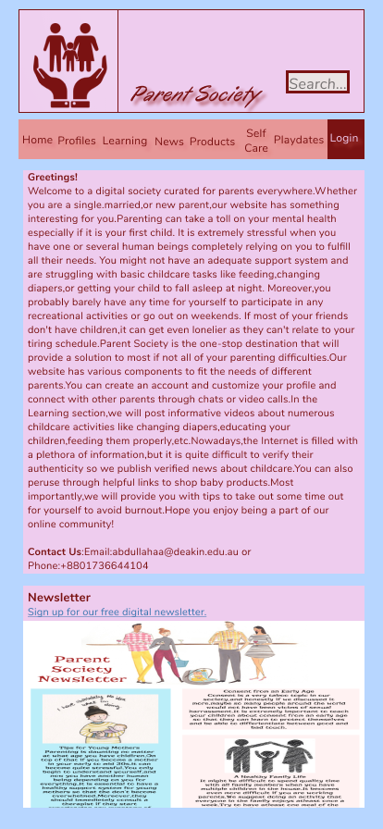

### Figma UI/UX Prototype

Figure 5 Mobile Home Page

Figure 6 Mobile Login Form

Figure 7 Mobile Newsletter Form

[Prototype for Desktop](https://www.figma.com/proto/WpSEMXNTpamrKwkWTgM6uR/index?node-id=2%3A7&scaling=min-zoom&page-id=0%3A1&starting-point-node-id=2%3A7)

[Prototype for Smartphone](https://www.figma.com/proto/aW5P4Cvi1p4SCPrN281JVe/Mobileindex?node-id=6%3A2&scaling=scale-down&page-id=0%3A1&starting-point-node-id=6%3A2)

# Larger System Summary

## Component Integrating

The following tree diagram depicts how the assets interact with each other in the preliminary stages. The components highlighted in blue access each other while the ones in white interact with each other.

app.vue

chat.vue

text.vue

register.vue

customprofile.vue

loginconfirm.vue

search.vue

Profiles.html

Proof-of-concept.html

## Concept Functionality

1. The user will log in by clicking the login button from the navigation bar in the Home page. If they are a first-time user, they will create a custom profile to interact with other parents. The website can remember their login information to keep the user logged in on a particular device.
2. Once they are logged in, they can interact with other parents on the Profiles page either through a chat or videocall function.
3. They can choose to watch instructive videos on the Learning page.
4. They can choose to read verified news articles on the News page.
5. They can choose to peruse through the shopping recommendation links in the Products page and be redirected to the e-commerce websites selling the products.
6. They can choose to complete the activities in the Self Care page and mark off their completed activities.
7. They can choose to read the suggestions in the Playdates page.
8. The search bar on the Home page will allow users to type in text to locate their desired titles, and the search function will list any matching entries.
9. The users can also fill in a form to receive monthly digital Newsletter through the hyperlink in the Home page.

## Development Schedule

|  |  |  |  |  |  |  |  |  |  |  |  |  |  |  |  |
| --- | --- | --- | --- | --- | --- | --- | --- | --- | --- | --- | --- | --- | --- | --- | --- |
| # | Tasks | Start | End | Days | Wk 1 | Wk2 | Wk3 | Wk 4 | Wk5 | Break | Wk 6 | Wk 7 | Wk 8 | Wk 9 | Wk 10 |
|  | Total Schedule | Wk2 Mon. | Wk1  Fri. | 60 |  |  |  |  |  |  |  |  |  |  |  |
| 1 | Project Proposal | Wk2 Mon. | Wk6Fri. | 15 |  |  |  |  |  |  |  |  |  |  |  |
| 2 | Proof-of-concept.html | Wk3 Mon. | Wk6 Fri. | 9 |  |  |  |  |  |  |  |  |  |  |  |
| 3 | Profiles.html | Wk7Mon. | Wk7  Wed | 3 |  |  |  |  |  |  |  |  |  |  |  |
| 4 | Learning.html | Wk7Thurs. | Wk7 Sat. | 3 |  |  |  |  |  |  |  |  |  |  |  |
| 5 | News.html | Wk8  Mon. | Wk8 Wed | 3 |  |  |  |  |  |  |  |  |  |  |  |
| 6 | Products.html | Wk8Thurs. | Wk8  Sat. | 3 |  |  |  |  |  |  |  |  |  |  |  |
| 7 | SelfCare.html | Wk9  Mon. | Wk9 Wed. | 3 |  |  |  |  |  |  |  |  |  |  |  |
| 8 | Playdates.html | Wk9 Thurs. | Wk9 Sat. | 3 |  |  |  |  |  |  |  |  |  |  |  |
| 9 | CSS Responsiveness | Wk 10  Mon. | Wk 10 Fri. | 5 |  |  |  |  |  |  |  |  |  |  |  |
| 10 | Final Changes | Wk 10 Thurs. | Wk 10 Sat. | 5 |  |  |  |  |  |  |  |  |  |  |  |

The whole website construction project begins on 19th July Monday and finishes on 24th September Friday. I started the Project Proposal in Week 2 and aim to complete it by Week 6 after I receive feedback from the first version. I began the Proof-of-concept.html in Week 3 and aim to complete it by Week 6 after implementing all necessary changes. I marked off 3 days each for the other pages and tried to keep 3 days’ worth of spare time to make sure everything works properly. Also, I did not include any working time during the intra-trimester break.